SVN to Stash Migration

- Keep SVN url that need to be migrated,
- Use the below commands in Git Bash
- mkdir migration
- cd migration
- git svn init “SVN URL”
- git svn fetch
// it will fetch all the code and copy in our local git repository created above folder.
- git init
- git add --all
- git commit –m “Initial Commit”
- git remote add origin ssh://git@stash-stg.concentra.com:7999/test/test.git
- git push origin master
// it will ask you to prompt for entering the password, enter stash password.
- Once the process completed, if you check in stash repository you can see all the svn code is migrated to stash now.
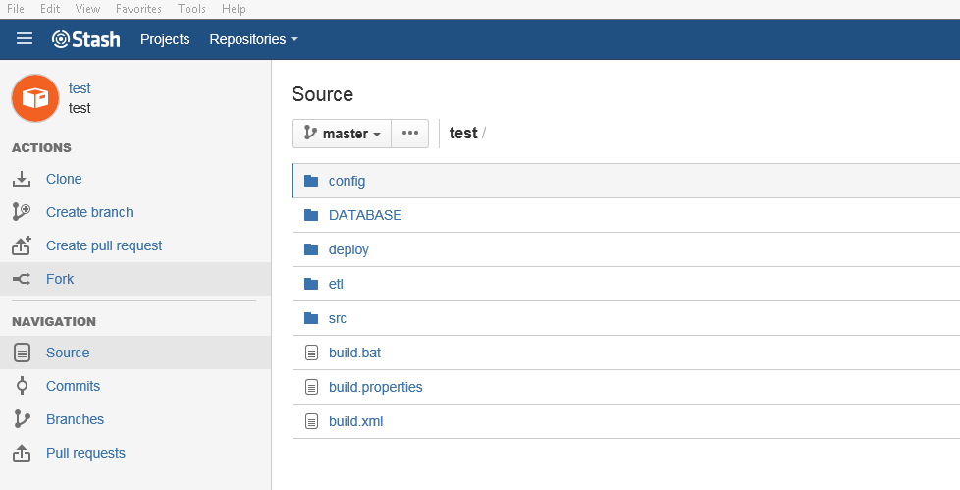

SVN to Stash migration is completed.

- Steps to create new branch using GitBash
- 